Case: 1: Flexible Budgeting
Larry’s Lawn Service provides lawn care in a planned community where all lawns are approximately the same size. At the end of May, Larry prepared his June budget based on
mowing 500 lawns. Since all of the lawns are similar in size, Larry felt that the number of lawns mowed in a month would be the best way to measure overall activity for his business. Lawry offered to types of service menu cards: 1. Normal/ regular service and 2. Premium service.
Larry identified 7 major expenses for his business. In addition, Larry estimated a cost formula for revenue and for each expense in terms of the number of lawns mowed. Revenue, along with each of the 7 major expense categories, and their relationship to the number of lawns (Q) is as follows:
- Revenue, $75 per lawn (Q)
- Wages and salaries, $5,000 + $30 per lawn (Q)
- Gasoline and supplies, $9Q
- Equipment maintenance, $3Q
Some expenses are not directly related to the number of lawns mowed. They are the fixed costs:
- Office and shop utilities, $1,000;
- Office and shop rent, $2,000;
- Equipment depreciation, $2,500; and insurance, $1,000.
Larry’s static planning budget is based on an activity level of 500 lawns.
Decision Point: Assume that Larry’s actual results for the month of June are as shown. Notice that Larry actually mowed 550 lawns.

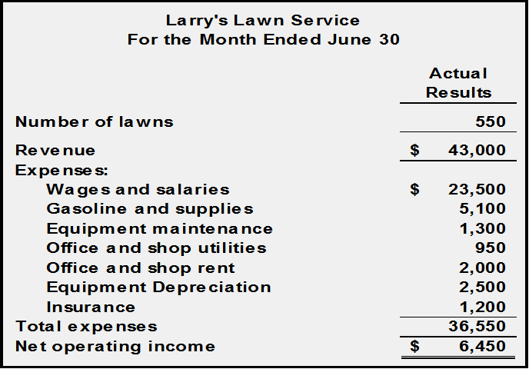

Statement of cost/Cost sheet

 | PARTICULARS |  |  | Rs. | Rs.
A | Raw Materials:
 |  | Op. Stock
 |  | Add Purchases
 |  | Less Cl..Stock
 |  | cost of raw materials used/consumed
B | Direct labour/Wages
C | Other Direct Charges
D |  |  | PRIME COST =A+B+C
 | Factory Overheads:
 |  | Indirect material
 |  | Indirect labour
 |  | Depreciation on factory building & equipment
 |  | Insurance
 |  | Repairs and maintenance-factory
 |  | Other factory overheads
E |  |  | Gross Factory cost
F | Add | WIP opening
G | Less | WIP Closing
H |  | FACTORY COST= D+E+F-G
 | Office and Administration Overheads:
 |  | Office salaries
 |  | Office rent, insurance, lighting
 |  | Other office overheads
I |  | Office Cost/cost of production
J | Add | Op.Stock of finished goods
K | Less | CL.stock of finished goods
L |  | COST OF GOODS SOLD = H+I+J-K
M | Selling and distribution overheads:
 |  | Sales staff salaries
 |  | Showroom expenses
 |  | Advertising
 |  | Carriage outwards
 |  | Packing
 |  | Bad Debts
M |  |  | Total Selling and distribution cost
O |  | COST OF SALES = L +M
P | Add |  | PROFIT
 |  |  | SALES PRICE = O+P

Example-1
Draw up a flexible budget for overhead expenses on the basis of the following data and determine the overhead rates at 70%, 80%, and 90% plant capacity. Figures are given at 80% capacity level.
Particulars | Rs.
Variable overheads:  Indirect labor  Stores including spares | 12,000  4,000
Semi Variable overheads:  Power (30% fixed)  Repairs and maintenance (40% variable) | 20,000  2,000
Fixed Overheads:
Depreciation  Insurance  salaries | 11,000  3,000  10,000
Estimated direct labor hours | 1,24,000

Example: 2
ABC Company Ltd. Has prepared a budget for the production of 1,00,000 units of the only commodity manufactured by them for a costing period as under:
Particular | Rs. (Per Unit)
Raw material | 2.52
Direct labor | 0.75
Direct Expenses | 0.10
Works overhead (60% fixed) | 2.50
Administrative overheads (80% fixed) | 0.40
Selling overheads (50% fixed) | 0.20
The actual production during the period was only 60,000 units. Calculate the revised budgeted cost per unit._______________________________________________-

